

July 17, 2012

After an Artist’s Death, His Home Becomes a Work of Art
By COREY KILGANNON
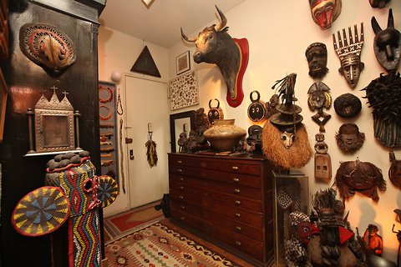Chester Higgins Jr./The New York Times The contents of the artist Barton Benes’s Westbeth apartment will be shipped to the North Dakota Museum of Art, where his home will be recreated for an exhibit.
Over the past 42 years, Barton Lidice Benes turned his dimly lighted apartment in Greenwich Village into a cave full of curios.
His home — apartment 956-H in the Westbeth artist residences on Bethune Street – was filled with what Mr. Benes called artifacts of everyday life.
The first thing one notices upon entering is the stuffed head of a bull, which came from Pamplona, Spain, and then a seven-foot-tall stuffed giraffe head and neck. There are more stuffed animals in addition to African masks and statues, religious relics, voodoo dolls and many other artifacts. There are also examples of Mr. Benes’s outrageous, humorous and poignant art. Mr. Benes, who was H.I.V.-positive, died of acute kidney failure on May 30 at age 69.
“The place was always an extension of him, but at the end, he became an extension of it,” said Mr. Benes’s younger brother, Warren Benes, 66, who then pointed to Mr. Benes’s elaborate wood-carved bed and said: “They call this a Chinese wedding bed. It was used for smoking opium.”
Warren Benes lives near Chicago but was in the apartment, along with his wife, Sam, on Tuesday to help prepare for it to be emptied, packed up and sent to the North Dakota Museum of Art in Grand Forks, which arranged with Mr. Benes before he died to reconstruct the apartment as an exhibition.
The museum had dared to show some of the artist’s controversial works over the years, including “Lethal Weapons,” a collection of 30 vessels, including a water pistol, filled with the artist’s or other people’s H.I.V.-infected blood. Other museums and galleries had been unwilling to show some of Mr. Benes’s more provocative works related to AIDS.
Some of his work will be shown in a show beginning Oct. 11 at the Pavel Zoubok Gallery on 23rd Street.
Barton Benes, one of the original residents of Westbeth, grew up in Corona, Queens. He called his 800-square-foot apartment his “tomb” and asked that his ashes, and those of his mother, Marie, who died in 2005, be kept on the bed with a view of the television set playing reruns of “Judge Judy,” in the museum exhibit.
Mr. Benes told his mother he wanted to mix their ashes together, and use them to stuff a pillow stitched by her own hand.
“She said, ‘Wouldn’t that be incest?’” Warren Benes recalled. “He said, ‘No, it’s like going back to the womb.’ She said, ‘Oh, that’s fine then.’”
Warren Benes hired a photographer, Brandon Remler, who was shooting images of the apartment. Also on hand was one of the artist’s friends, Bob Brier, an Egyptologist from the Bronx and a professor at Long Island University who supplied Barton Benes with mummified objects from his own unusual collection of Egyptian items that he keeps in three adjacent apartments in Riverdale in the Bronx.
Mr. Benes had said that he saw so many friends’ apartments being tossed out after they died of AIDS, that he became a curator of his own place. Also, his outrage over the toll the AIDS epidemic took among his group of friends led him to make works out of cremated ashes and his own H.I.V.-infected blood.
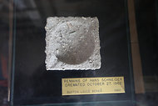
Chester Higgins Jr./The New York Times
Among the collection of the deceased artist are the remains of AIDS victims.

In various drawers and other spaces, Mr. Benes kept thousands of items, including human bones and a blackened human toe found on the Williamsburg Bridge. There was the framed gallstone removed from his friend Larry Hagman, the actor, and a collector of Barton Benes’s work.
Mr. Brier reached into one of Mr. Benes’s drawers and randomly pulled out a Ziploc bag. It contained the ashes of two friends of Mr. Benes who died of AIDS, along with their passports. Then he pulled out a small wooden box labeled “Vitamin Chest,” which contained six glass bottles, each containing the ashes of a different friend of Barton Benes.
Mr. Benes became so well known for collecting artifacts and turning them into art, that he developed a vast network of friends who would send him such relics – often they were items discarded by celebrities.
Mr. Brier showed an artwork Mr. Benes made from napkins used by Brooke Shields, Robert DeNiro, Nancy Reagan and others.
Mr. Brier said that Mr. Hagman’s mother, the actress Mary Martin, grabbed a bunch of jelly beans in her purse when in the Oval Office once, while meeting Ronald Reagan, and gave them to Barton Benes.
“So many people knew that Barton collected these things for his artwork, and they would grab them and send them to him,” Mr. Brier said.

