PRESS RELEASE December 2006

ALBERT HOFFMAN, SCULPTOR OF WOOD

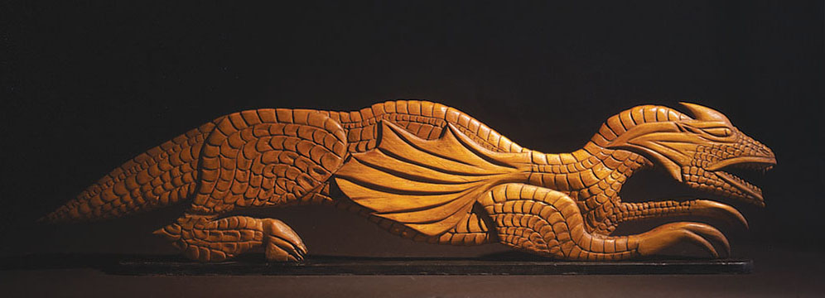
Dragon, ca. 1978, 11 x 51 x 1.5 inches, spruce

Andrew Edlin Gallery is pleased to present Albert Hoffman, Sculptor of Wood, on view from
January 18 – March 3, 2007.

Born in Philadelphia, Albert Hoffman (1915 – 1993) had a formal education that extended to the 8th grade, when it was cut short by the pressures of the Great Depression. He joined the Navy just after the attack on Pearl Harbor and was wounded in action. After the war he returned east to Atlantic City, settling in nearby Absecon where he went into the junk business. Shortly thereafter, Hoffman began to spend increasing amounts of his time carving simple reliefs

Hoffman's oeuvre covers a wide range of subjects, including sea imagery, strange beasts, the Devil, as well as figures from Greek myths and American folklore. It is of no small significance that the Old Testament consumed so much of the artist’s attention, the major portion of his output deriving as it does from Judaic content. Hoffman’s boyhood was filled with the anecdotal lessons of Jewish lore, as handed down by his father in particular.

While Hoffman worked in other media, including painting and repousé copper, his most prolific work was in wood. Although the artist occassionally painted his reliefs and some of his smaller works, many were left in their natural wood states. The carved and painted reliefs are pictorial panels done on two-inch thick slabs of mahogany against shallow backgrounds. While many of Hoffman’s free-standing works rely less on their immediate forms to draw attention, several are especially compelling due to their striking contours. At times, Hoffman achieves a stylization which recalls Brancusi, exploiting the flow of the woodgrain and shaping his figures into modernist forms which capture the grace of each in celebration of nature’s own design.

Like many self-taught artists, Albert Hoffman created his works primarily for himself. The artist and filmmaker, Herbert Danska, discovered Hoffman in Atlantic City, NJ, encountering his work at a small boardwalk museum in 1988. The sculptor’s reputation had been strictly limited to the area. Since Hoffman's death in 1993, Danska has introduced his work to a growing audience through exhibitions at the American Visionary Art Museum (Baltimore, 1995, 2001), the Noyes Museum of Art (Oceanville, NJ, 1997) the Luise Ross Gallery (New York City, 1999) and the American Folk Art Museum (New York, NY 2002).

Andrew Edlin Gallery 529 West 20th Street, NYC 10011 212.206.9723 edlingallery.com

