PRESS RELEASE February 2006

Andrew Edlin Gallery is pleased to announce its second solo exhibition for Brooklyn-based,
Irish artist John Spinks entitled, Letters from Wallsend. This exhibition features a series of recent collage on canvas works and is on view from March 16, 2006 through April 29, 2006.

The works in this series are harmonious compilations of precisely juxtaposed parts including found images, paper, lightly painted acrylic, and most notably, actual letters sent by Spinks’ father to him from Wallsend, a small town in northern England.

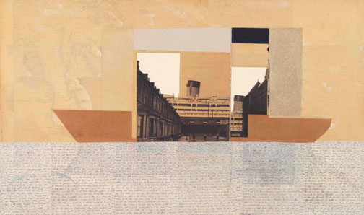
I have lived in the U.S. for twenty-five years and I exchanged weekly letters with my father in Wallsend for much of that time. As an ex-teacher of English and Drama I have retained a respect for the written word. I am interested in the handwritten letter as a form and suspect that in the foreseeable future the hand-written message will become extinct.
–John Spinks
Approaches to Mass, 25”x 42”, 2005

In Approaches to Mass (above), the parts create a symbolic language of their own and touch upon our individual perceptions of time, space, memory and history.

Spinks creates poetic vignettes through this new language and dedicated formalism that speaks to his own Irish tradition of narrative history.

This body of work also focuses on specific personal objectives as Spinks is mainly fascinated with the hand-written letter as a form. He also addresses media’s obsession with lionizing people in contemporary culture:

Meanwhile millions of ordinary people live exemplary lives and pass away in total anonymity. My father was such a person...His letters reflect the strength of the community of which he was a part. Making them an integral aspect of artwork is testimony to that strength.

John Spinks is a self-taught artist who began creating mixed-media collages over a decade ago. His work has been exhibited in the United States and Europe and is included in many distinguished private and corporate collections.

This exhibition will travel in the summer to Buddle Arts Centre in Wallsend, England and will be curated by Jessica Bell. It will be on view there from July 10 – August 14, 2006.

Andrew Edlin Gallery 529 West 20th Street, NYC 10011 212.206.9723 edlingallery.com

